PROJECT REPORT
ONLINE QUIZ SYSTEM USING CORE JAVA

Submitted by Abhishek Saini (24BCS10239) Mayank Yadav (24BCS10299)
Diwakar Kumar (24BCS10275) Arman Sharma (24BCS12423) Rishi Dabbeeru (24BCS10344)

in partial fulfillment for the award of the degree of

BACHELOR OF ENGINEERING
IN
COMPUTER SCIENCE AND ENGINEERING


Chandigarh University
April 2026



BONAFIDE CERTIFICATE

Certified that this project report “ONLINE QUIZ SYSTEM USING CORE JAVA” is the Bonafide work of “ABHISHEK SAINI, MAYANK YADAV, DIWAKAR KUMAR, ARMAN SHARMA, RISHI DABBEERU” who carried out
the project work under my supervision.

SIGNATURE SIGNATURE

DR. JASPREET SINGH ER. PARVESH KUMAR

HEAD OF THE DEPARTMENT SUPERVISOR
Asst. Professor

Submitted for the project viva-voce examination held on

INTERNAL EXAMINER EXTERNAL EXAMINER

TABLE OF CONTENTS

ABSTRACT 5
CHAPTER 1. INTRODUCTION 6
  - Identification of Client / Need / Relevant Contemporary Issue 6
  - Identification of Problem 6
  - Identification of Tasks 7
  - Timeline 7
  - Organisation of the Report 8
CHAPTER 2. LITERATURE REVIEW/BACKGROUND STUDY 9
  - Timeline of the Reported Problem 9
  - Existing Solutions 9
  - Bibliometric Analysis 9
  - Review Summary 10
  - Problem Definition 10
  - Goals / Objectives 10
CHAPTER 3. DESIGN FLOW/PROCESS 11
  - Evaluation & Selection of Specifications / Features 11
  - Design Constraints 11
  - System Architecture 12
  - Data Flow Diagrams (DFD Level 0 & Level 1) 13,14
  - Entity Relationship (ER) Diagram 15
  - Database Design & Class Diagram 16
  - Implementation Plan / Methodology 17
  - Detailed Module Design 18
  - Process Flowchart 19
CHAPTER 4. RESULTS ANALYSIS AND VALIDATION 20
  - Implementation of Solution 20
  - Testing Strategy 21
  - Test Cases 21
  - Results Analysis 22
  - Validation 22
CHAPTER 5. CONCLUSION AND FUTURE WORK 23
  - Conclusion 23
  - Future work 24
Advantages and Limitations 25
Comparison: Manual vs Online System 25
References 26

ABSTRACT
This project focuses on analyzing the relationship between discounts and profit using the Sample Superstore dataset. The primary objective is to understand how discount strategies influence business profitability and to identify patterns that can support better pricing decisions.
The study applies basic data analytics techniques, including data preprocessing, statistical analysis, correlation computation, and data visualization. Key performance indicators such as profit margin and correlation coefficient are calculated to evaluate business performance. The correlation analysis reveals a negative relationship between discount and profit, indicating that higher discounts generally lead to lower profits.
To support the findings, multiple visualizations such as scatter plots, line charts, heatmaps, and pie charts are used to represent the data effectively. These visual tools help in clearly understanding trends and relationships within the dataset. Additionally, performance evaluation and cross-validation techniques are used to assess the reliability of the results.
The study concludes that while discounts can help increase sales, excessive discounting negatively impacts profitability. Therefore, businesses must adopt a balanced and data-driven approach to pricing strategies. The project demonstrates how data analytics can be effectively used to derive meaningful insights and support strategic business decisions.

CHAPTER 1

INTRODUCTION

Identification of Client /Need / Relevant Contemporary issue

Sales analytics has evolved into a core pillar of modern business intelligence, enabling organizations to make data-driven decisions that directly influence profitability and competitive positioning. In retail environments—both physical and digital—pricing strategies and discount mechanisms are critical levers that shape consumer behavior, demand patterns, and revenue generation.

Discounting is widely used to stimulate demand, clear inventory, and attract price-sensitive customers. However, its relationship with profit is inherently complex. While higher discounts often lead to increased sales volume, they simultaneously reduce profit margins, creating a trade-off that requires careful optimization. Empirical observations across retail sectors indicate that this relationship is rarely linear and is influenced by multiple factors such as product category, customer segment, seasonality, and market competition.

In highly competitive markets, businesses frequently adopt dynamic pricing strategies, where discounts are adjusted in real time based on demand fluctuations, inventory levels, and competitor actions. This shift toward dynamic pricing has increased the importance of understanding how incremental changes in discount levels impact both short-term revenue and long-term profitability. Additionally, consumer purchasing behavior has become increasingly data-driven, with customers actively comparing prices across platforms, making pricing decisions even more critical for businesses.

The rapid growth of e-commerce platforms has further intensified the use of discount strategies. Online retailers often rely on aggressive promotional campaigns, flash sales, and personalized discounts to capture market share. While these strategies can significantly boost transaction volume, they also introduce challenges related to margin sustainability and customer expectations, as frequent discounts may condition customers to delay purchases until price reductions are offered.

With the rise of big data and advanced analytics, organizations now employ statistical models, machine learning algorithms, and business intelligence tools to better understand these relationships. Techniques such as regression analysis, correlation analysis, and time-series forecasting allow businesses to quantify the impact of discount strategies on profitability and optimize decision-making processes. These analytical approaches enable organizations to move beyond intuition-based decision-making toward evidence-based strategies.

Furthermore, modern analytics systems integrate multiple data sources, including transactional data, customer demographics, and behavioral patterns, to provide a comprehensive view of sales performance. This integration allows for more accurate demand forecasting, improved inventory management, and targeted marketing strategies. As a result, businesses can design more effective discount policies that balance revenue growth with profitability.

Another important aspect of sales analytics is the identification of optimal discount thresholds. Research and practical observations suggest that moderate discounts often yield the best balance between increased sales and maintained profit margins, whereas excessive discounting leads to diminishing returns. Understanding these thresholds is essential for developing sustainable pricing strategies.

In addition, the increasing adoption of artificial intelligence and predictive analytics has enabled businesses to simulate various pricing scenarios and evaluate their potential outcomes before implementation. This capability enhances decision-making by reducing uncertainty and minimizing financial risk.

Overall, the study of discount and profit relationships forms a critical component of modern retail analytics. By leveraging advanced data analytics techniques, organizations can better understand the underlying patterns, optimize pricing strategies, and achieve sustainable competitive advantage in an increasingly data-driven marketplace.

Identification of Problem

In modern retail and e-commerce environments, pricing strategies—particularly discount mechanisms—play a crucial role in influencing sales performance and overall profitability. However, organizations face significant challenges in accurately identifying how discounts impact profit outcomes. The core problem lies in the lack of a clear, data-driven understanding of the relationship between discount levels and profitability.
Many businesses implement discount strategies to increase sales volume, attract new customers, or clear excess inventory. While these objectives are often achieved, the unintended consequence is a reduction in profit margins, which may offset the benefits of increased sales. This creates a fundamental dilemma: higher discounts can drive revenue growth but may simultaneously erode profitability. Without proper analytical frameworks, businesses struggle to determine the optimal balance between these competing objectives.
Another critical issue is the over-reliance on intuition and traditional decision-making approaches. In many cases, pricing decisions are made based on past experience, market trends, or competitor actions rather than rigorous data analysis. This leads to inconsistent discount policies and suboptimal outcomes, especially in dynamic and competitive markets where consumer behavior changes rapidly.
Additionally, the relationship between discount and profit is influenced by multiple interacting variables such as product category, customer segment, purchase quantity, seasonality, and market demand. The presence of these factors makes the relationship multi-dimensional and non-linear, which cannot be effectively captured using simple analytical methods. As a result, businesses often fail to identify hidden patterns and dependencies that significantly impact profitability.
The lack of integrated data analytics systems further compounds the problem. In many organizations, sales data is fragmented across different platforms and departments, making it difficult to perform comprehensive analysis. Without centralized and well-structured data, it becomes challenging to apply advanced techniques such as correlation analysis, regression modeling, and predictive analytics.
Another key problem is the absence of real-time monitoring and performance evaluation. Businesses often analyze sales and profit data retrospectively, which limits their ability to respond quickly to changing market conditions. Without real-time insights, organizations cannot adjust discount strategies dynamically to optimize outcomes.
Moreover, there is a limited focus on measuring discount effectiveness using appropriate key performance indicators (KPIs). Metrics such as profit margin, discount efficiency, and return on discount investment are not consistently tracked, leading to incomplete evaluation of pricing strategies.
In summary, the identification of the problem highlights several critical gaps:
- Inadequate understanding of the discount–profit relationship
- Lack of data-driven decision-making frameworks
- Complexity due to multiple influencing factors
- Fragmented and unstructured data systems
- Absence of real-time analytics and monitoring
- Insufficient use of performance metrics
These challenges emphasize the need for a comprehensive data analytics approach that can accurately model the relationship between discount and profit, uncover hidden patterns, and support informed decision-making. Addressing these problems is essential for developing effective pricing strategies that maximize profitability while maintaining competitive advantage.

Aim of the Project

The primary aim of this project is to systematically analyze the relationship between discount levels and profit using advanced data analytics techniques, and to develop a robust, data-driven framework that supports organizations in optimizing their pricing strategies for enhanced profitability and sustainable growth.
This project seeks to move beyond traditional intuition-based decision-making by leveraging quantitative methods to uncover patterns, relationships, and trends within sales data. By applying statistical analysis, correlation techniques, and predictive modeling, the study aims to provide a clear understanding of how discount strategies influence profit outcomes across different scenarios.
In addition to analyzing the strength and direction of the relationship between discount and profit, the project focuses on identifying optimal discount ranges that balance increased sales volume with acceptable profit margins. The objective is not only to evaluate existing pricing practices but also to propose improved strategies that minimize profit erosion while maintaining competitiveness in the market.
Furthermore, the project aims to design an analytical framework that can be implemented using modern tools and technologies such as Python-based data analytics libraries and visualization techniques. This framework will enable businesses to perform continuous monitoring, generate actionable insights, and make informed pricing decisions based on real-time data analysis.
Ultimately, the project aspires to contribute to the field of sales analytics by demonstrating how data-driven approaches can enhance decision-making processes, improve operational efficiency, and environment.

Detailed Aims of the Project

To analyze the correlation between discount and profit:Evaluate the strength and direction of the relationship between discount percentages and profit values using correlation techniques, identifying whether the relationship is positive, negative, or neutral.

To understand the impact of discount levels on profitability: Examine how different discount ranges influence profit margins, sales volume, and revenue, and identify patterns such as diminishing returns at higher discount levels.

To apply statistical and machine learning techniques: Utilize methods such as regression analysis, exploratory data analysis, and predictive modeling to quantify relationships and forecast profit outcomes based on discount strategies.

To identify optimal discount ranges: Determine discount levels that maximize profitability while maintaining competitive pricing and customer engagement.

To develop a data-driven analytical framework: Design a structured pipeline that includes data preprocessing, analysis, modeling, and visualization for systematic evaluation of pricing strategies.

To enhance decision-making through data insights:Provide actionable insights that enable businesses to make informed pricing decisions rather than relying on assumptions or traditional methods.

To visualize key relationships and trends: Use graphs such as scatter plots, heatmaps, and line charts to clearly represent the relationship between discount and profit for better interpretation.

Objective of the Project

The objectives of this project are defined to achieve a structured and measurable approach toward analyzing and optimizing the discount-profit relationship. Each objective contributes to building a comprehensive data analytics framework that supports effective decision-making.

Detailed Objectives

To study the relationship between discount levels and profit margins:Analyze how varying discount percentages influence profit margins across transactions. This includes identifying whether the relationship is direct, inverse, or non-linear, and understanding the trade-offs between increased sales volume and reduced profitability.

To apply statistical techniques such as correlation and regression analysis:Utilize quantitative methods to measure and model the relationship between discount and profit. Correlation analysis helps determine the strength and direction of the relationship, while regression analysis is used to predict profit outcomes based on discount levels and other influencing factors.

To identify patterns across different retail channels and product categories:Examine how the discount-profit relationship varies across multiple sales channels (e.g., e-commerce, retail stores) and product categories (e.g., luxury, grocery, electronics). This helps in understanding segment-specific behavior and tailoring pricing strategies accordingly.

To design a Key Performance Indicator (KPI) framework for monitoring discount effectiveess:Develop a set of measurable indicators such as profit margin, revenue, discount efficiency, and sales growth. These KPIs enable continuous monitoring and evaluation of discount strategies to ensure they align with business goals.

To develop visualization dashboards for decision support:Create interactive and intuitive visual representations such as scatter plots, bar charts, heatmaps, and trend lines. These dashboards assist stakeholders in quickly interpreting data, identifying trends, and making informed decisions.

To provide actionable insights for pricing optimization:Translate analytical findings into practical recommendations that help organizations determine optimal discount levels, improve pricing strategies, and enhance overall profitability.
To perform exploratory data analysis (EDA) for deeper understanding:Investigate data distributions, detect outliers, and uncover hidden trends that may influence the discount-profit relationship.

To evaluate the impact of discount ranges on sales performance:Analyze different discount brackets to understand how they affect sales volume, revenue generation, and profitability.

To ensure scalability and adaptability of the analytical model:Design the solution in a way that it can be applied to different datasets, industries, or business scenarios with minimal adjustments.

Scope of the Project

The scope of this project defines the boundaries, coverage, and applicability of the study, focusing on analyzing the relationship between discount strategies and profitability using data analytics techniques. The project is designed to provide a structured and practical approach to understanding pricing dynamics within a controlled analytical environment.

Scope Coverage
Retail Sales Data Analysis Across Multiple Channels:The project focuses on analyzing transactional sales data obtained from various retail channels such as e-commerce platforms, physical stores, and warehouse-based retail systems. This multi-channel perspective allows for a comparative understanding of how discount strategies impact profitability in different operational contexts.
Use of Python-Based Analytics Tools for Modeling and Visualization:The analysis is performed using Python as the primary programming environment. Libraries such as pandas, NumPy, Matplotlib, Seaborn, and scikit-learn are utilized for data preprocessing, statistical analysis, and visualization. This ensures a flexible, scalable, and reproducible analytical workflow.
Application of Statistical and Machine Learning Methods:The project incorporates both traditional statistical techniques and modern machine learning approaches. Methods such as correlation analysis, regression modeling, and exploratory data analysis are used to identify relationships, while predictive techniques help estimate profit outcomes based on discount levels.
Development of Business Intelligence Dashboards:Visualization plays a key role in the project, with the development of dashboards that present insights in an interactive and user-friendly manner. These dashboards include charts, graphs, and key performance indicators (KPIs) that assist stakeholders in understanding trends and making informed decisions.
Analysis of Discount Strategies and Profit Behavior:The study specifically examines how varying discount levels influence profit margins, sales volume, and revenue generation. It identifies patterns, optimal discount ranges, and potential risks associated with aggressive discounting.
Predictive Modeling for Decision Support:The project includes predictive analysis to forecast profit outcomes under different discount scenarios. This helps in evaluating potential strategies before implementation, supporting proactive decision-making.

Out of Scope
Real-Time System Deployment:The project does not include the deployment of the analytical framework in a live production environment. All analyses are performed on static or pre-collected datasets.
Integration with Enterprise Systems:The system is not integrated with real-time enterprise resource planning (ERP), customer relationship management (CRM), or live retail systems.
Advanced Automation and Live Data Streaming:Real-time data streaming, automated decision systems, and continuous monitoring pipelines are beyond the scope of this project.

CHAPTER 2

LITERATURE REVIEW/BACKGROUND STUDY

Background

Sales analytics has emerged as a fundamental component of modern business intelligence, enabling organizations to leverage data for strategic decision-making and competitive advantage. In today’s highly dynamic and data-driven market environment, businesses rely heavily on analytical insights to optimize operations, enhance customer satisfaction, and maximize profitability. Among the various aspects of sales analytics, pricing strategies—particularly discount mechanisms—play a crucial role in influencing consumer behavior, demand patterns, and overall revenue generation.
In retail environments, both physical and digital, discounts are widely used as a strategic tool to attract customers, increase sales volume, and manage inventory effectively. Businesses often implement discounts during promotional campaigns, seasonal sales, or clearance periods to stimulate demand. While such strategies can significantly boost transaction volumes, they also introduce complexity in determining their actual impact on profitability. This is because an increase in sales does not necessarily translate into higher profits, especially when margins are reduced due to aggressive discounting.
The relationship between discount and profit is inherently complex and involves a critical trade-off. On one hand, higher discounts can drive customer engagement and increase purchase frequency. On the other hand, they directly reduce the per-unit profit margin, which may lead to an overall decline in profitability if not managed properly. This trade-off makes it essential for businesses to identify optimal discount levels that balance increased sales with sustainable profit margins.
Furthermore, the discount-profit relationship is rarely linear. It is influenced by a wide range of factors including product category, customer segmentation, purchasing behavior, seasonal variations, and competitive market conditions. For instance, premium products may maintain profitability even with moderate discounts due to higher base prices, whereas low-margin products may experience significant profit erosion even with small discounts. Similarly, customer sensitivity to discounts varies across segments, making it necessary to adopt targeted pricing strategies rather than a one-size-fits-all approach.
With the rapid growth of e-commerce and digital platforms, the importance of understanding pricing dynamics has increased significantly. Online marketplaces often employ dynamic pricing strategies, where discounts are adjusted in real time based on demand fluctuations, inventory levels, and competitor pricing. This has further complicated the pricing landscape, requiring more sophisticated analytical approaches to ensure optimal decision-making.
The advancement of big data technologies and computational tools has enabled organizations to analyze large volumes of transactional data with greater accuracy and efficiency. Modern data analytics techniques, including statistical modeling, machine learning algorithms, and predictive analytics, provide powerful mechanisms to uncover hidden patterns and relationships within sales data. Methods such as correlation analysis help quantify the strength and direction of relationships between variables, while regression models enable prediction of profit outcomes based on discount levels and other influencing factors.
In addition, time-series analysis allows organizations to understand temporal trends and seasonal variations in sales and profitability. By integrating these techniques, businesses can move beyond descriptive analysis and adopt predictive and prescriptive analytics, enabling them to forecast outcomes and optimize pricing strategies proactively.
Another significant development in this domain is the use of business intelligence tools and interactive dashboards. These tools provide real-time visualization of key performance indicators, allowing decision-makers to monitor discount effectiveness, identify trends, and make informed adjustments quickly. The integration of analytics into business processes has transformed traditional decision-making approaches into data-driven systems that enhance efficiency and reduce uncertainty.
Overall, the study of the relationship between discount and profit represents a critical area of sales analytics. Understanding this relationship is essential for designing effective pricing strategies that not only drive sales but also ensure long-term profitability. By leveraging advanced data analytics techniques, organizations can gain deeper insights into customer behavior, optimize discount policies, and achieve sustainable growth in an increasingly competitive marketplace.

Problem Statement

Despite the widespread adoption of discount-based pricing strategies in retail and e-commerce, organizations continue to face significant challenges in accurately assessing their impact on overall profitability. While discounts are commonly used to attract customers, increase sales volume, and remain competitive in the market, their effect on profit is often misunderstood or inadequately analyzed. Many businesses still rely on intuition, historical trends, or basic descriptive statistics rather than adopting comprehensive data-driven approaches to evaluate pricing decisions.
A key issue lies in the complex and multi-dimensional relationship between discount levels, sales volume, and cost structures. Although higher discounts typically lead to increased customer demand and transaction volume, they simultaneously reduce per-unit profit margins. This creates a trade-off that is difficult to quantify without proper analytical tools. In many cases, organizations focus primarily on revenue growth while overlooking the impact on profitability, resulting in decisions that may boost short-term sales but harm long-term financial performance.
Another critical concern is the consistent observation of a negative relationship between discount percentages and profit margins. As discount rates increase, profit margins tend to decline, often at a faster rate than the increase in sales volume. Despite this, businesses frequently adopt aggressive discounting strategies without a clear understanding of their consequences. This lack of insight leads to several operational and strategic inefficiencies.
The primary problems arising from this scenario include:

Profit erosion despite increased sales volume:
Higher discounts may generate more sales, but the reduced margins often lead to lower overall profit, making the strategy unsustainable in the long run.
Inefficient pricing strategies:
Without proper analysis, organizations may apply uniform discount policies across different products and customer segments, ignoring variations in demand elasticity and profit contribution.
Lack of data-driven decision-making:
Decisions based on assumptions rather than analytical evidence result in suboptimal outcomes and missed opportunities for optimization.
In addition to these challenges, the absence of integrated analytical frameworks further complicates the situation. Many organizations lack the capability to process and analyze large volumes of sales data effectively. This limits their ability to uncover hidden patterns, identify optimal discount levels, and predict future outcomes. Furthermore, the dynamic nature of modern markets—characterized by changing customer preferences, competitive pricing, and seasonal demand—requires continuous monitoring and adaptation, which cannot be achieved through traditional methods alone.
Therefore, there is a clear need for a systematic and data-driven analytical framework that can evaluate the relationship between discount and profit with greater accuracy. Such a framework should incorporate statistical analysis, machine learning techniques, and visualization tools to provide actionable insights. By leveraging these techniques, organizations can better understand the impact of discount strategies, identify optimal pricing levels, and make informed decisions that balance sales growth with profitability.
In summary, the problem addressed in this project is the lack of an effective analytical approach to understand and optimize the discount-profit relationship, which is essential for achieving sustainable business performance in a competitive environment.

Overview of Sales Analytics Research
Extensive research in sales analytics emphasizes the critical role of pricing and discount strategies in shaping profitability outcomes. Analytical studies consistently demonstrate that while discounts can drive higher sales volumes, they often lead to reduced profit margins, resulting in a generally negative correlation between discount levels and profit. To better understand and validate these findings, both statistical analysis and graphical representations are essential.

A. Sample Dataset for Overview Analysis
To illustrate the relationship, a representative dataset structure used in sales analytics research is shown below:

Table 2.1: Sample Sales Dataset
Transaction ID | Discount (%) | Profit ($) | Sales ($) | Category | Channel
T001 | 5 | 8200 | 25000 | Luxury | Mall
T002 | 10 | 7500 | 23000 | Premium | Retail
T003 | 20 | 6100 | 21000 | Electronics | E-commerce
T004 | 30 | 4800 | 18000 | Fashion | E-commerce
T005 | 40 | 3500 | 15000 | Grocery | Supermarket
T006 | 15 | 6900 | 22000 | Premium | Retail
This dataset reflects typical patterns observed in retail analytics, where profit decreases as discount increases.

B. Correlation Analysis
The strength of the relationship between discount and profit is measured using Pearson correlation.

Correlation Formula

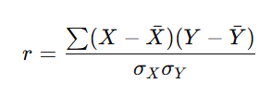
Where:
- XXX = Discount
- YYY = Profit

Observed Result
- Correlation Coefficient (r) ≈ -0.32 to -0.37
- Indicates a moderate negative relationship

C. Graphical Representation

1. Scatter Plot: Discount vs Profit
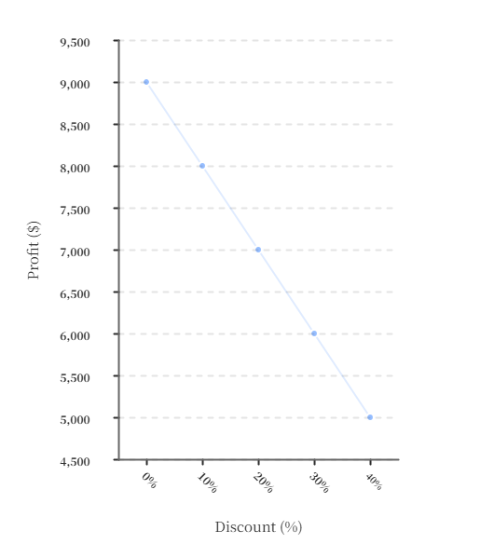

2. Regression Line Representation
The regression equation can be expressed as:
Profit=β0+β1(Discount)
Typical slope:
- β₁ ≈ -100 to -150

3. Heatmap (Correlation Matrix)

Variable | Discount | Profit | Sales
Discount | 1.00 | -0.34 | +0.45
Profit | -0.34 | 1.00 | +0.62
Sales | +0.45 | +0.62 | 1.00
Insights:
- Discount ↘ Profit (negative)
- Discount ↗ Sales (positive)
- Sales ↗ Profit (positive but weaker than margin effect)

D. Advanced Model Performance

Table 2.2: Model Comparison

Model | Accuracy (R²) | Key Advantage
Linear Regression | 0.65 – 0.75 | Simple interpretation
Ridge Regression | 0.90 – 0.98 | Handles multicollinearity
XGBoost | 0.97 – 0.99 | Captures complex patterns
LSTM | 0.92 – 0.96 | Time-based forecasting
ARIMA | ~0.90 | Seasonal trend modeling

E. Time-Series Trend Example

Monthly Discount vs Profit Trend
Month | Avg Discount (%) | Profit ($)
Jan | 18 | 4.2M
Feb | 19 | 4.0M
Mar | 20 | 3.8M
Apr | 18 | 4.3M
May | 19 | 4.1M
F. Key Insights from Overview
- Discount and profit exhibit a consistent negative correlation
- Sales volume increases with discount but not enough to offset margin loss
- Advanced models like XGBoost outperform traditional regression
- Time-series models capture seasonality and trend patterns
- Data analytics significantly improves pricing decision accuracy

Python Analytics Ecosystem

Python has become the leading platform for data analytics due to its extensive ecosystem of libraries, ease of use, and strong community support. It provides a complete environment for performing end-to-end data analysis, from data collection and preprocessing to advanced modeling and visualization. In the context of sales analytics and discount-profit analysis, Python enables efficient handling of large datasets and implementation of sophisticated analytical techniques.

Core Libraries and Their Roles
pandas → Data Manipulation and Analysis:The pandas library is widely used for handling structured data in the form of DataFrames. It provides powerful functionalities for data cleaning, transformation, filtering, aggregation, and merging datasets. In this project, pandas is used to preprocess sales data, handle missing values, and perform grouping operations such as analyzing profit by discount ranges or product categories.
NumPy → Numerical Computation:NumPy forms the backbone of numerical computing in Python. It supports efficient array operations, mathematical functions, and linear algebra computations. It is particularly useful for performing vectorized operations, which significantly improve performance when working with large datasets.
scikit-learn → Machine Learning and Modeling:scikit-learn is a comprehensive library for implementing machine learning algorithms. It provides tools for regression, classification, clustering, and model evaluation. In this project, it is used for applying regression models to predict profit based on discount levels and for evaluating model performance using metrics such as R² score and mean squared error.
Matplotlib and Seaborn → Data Visualization:Matplotlib and Seaborn are used for creating visual representations of data. Matplotlib provides basic plotting capabilities, while Seaborn builds on top of it to offer more advanced and aesthetically pleasing statistical visualizations. These libraries are used to generate scatter plots, heatmaps, histograms, and trend lines to visually analyze the relationship between discount and profit.

End-to-End Analytics Workflow Using Python
The Python ecosystem supports a complete analytical pipeline, which can be summarized as follows:
adjustments.
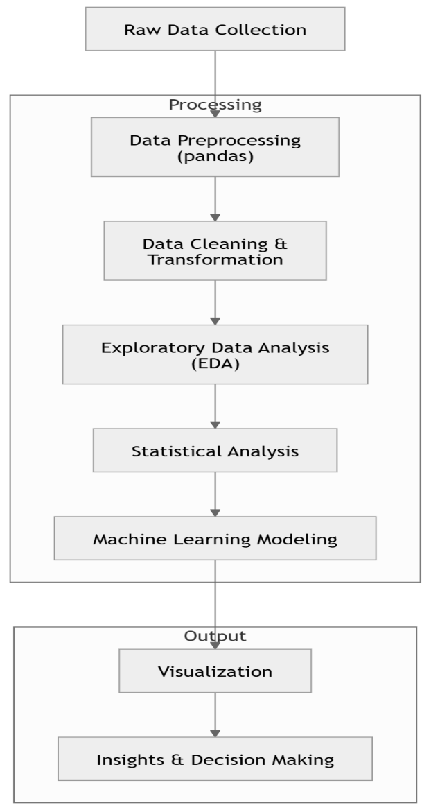

Research Gaps

Despite significant advancements in data analytics and machine learning applications, several critical research gaps remain:
Limited emphasis on causal inference:Most existing studies rely heavily on correlation-based analysis, which identifies relationships but fails to establish cause-and-effect dynamics. This limits the ability to make reliable strategic decisions.
Lack of cross-channel comparative analysis:Current research often focuses on single-channel datasets (e.g., online or offline sales) without integrating multiple channels. This restricts a holistic understanding of consumer behavior across platforms.
Insufficient integration of real-time analytics:Many analytical models operate on historical data, lacking mechanisms for real-time or near-real-time decision-making, which is crucial in dynamic business environments.
Minimal adoption of explainable AI (XAI):While machine learning models achieve high predictive performance, they often function as “black boxes,” offering limited interpretability. This reduces trust and usability in practical decision-making contexts.
To address these limitations, this project proposes a unified analytical framework that integrates exploratory data analysis, statistical modeling, and machine learning techniques. Additionally, it emphasizes causal insights, cross-channel data integration, real-time analytics capabilities, and the incorporation of explainable AI methods to enhance transparenc
.

CHAPTER DESIFLOW/PR0CESS

System Architecture

The proposed system follows a layered architecture, ensuring modularity, scalability, and clear separation of concerns. Each layer is responsible for a specific set of operations, enabling efficient data flow from raw input to actionable insights. This structured approach enhances maintainability and allows independent modification or extension of system components.

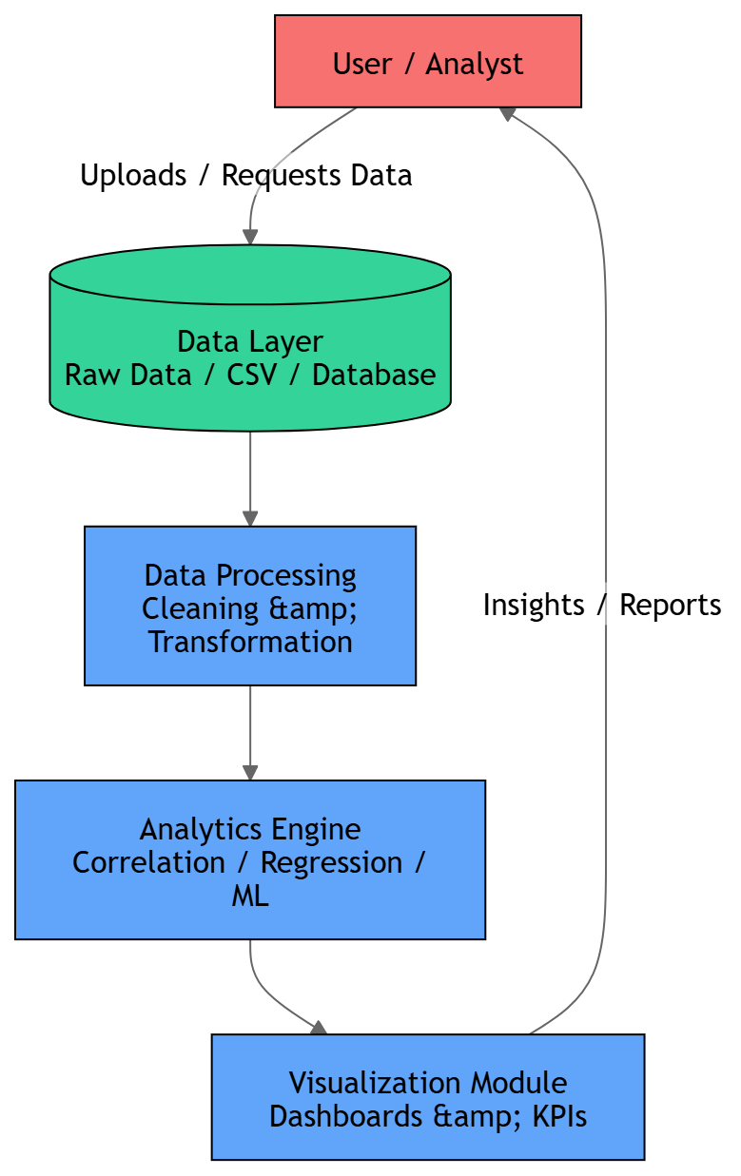

Detailed Description of Each Layer

1. Data Layer
The Data Layer serves as the foundation of the system, responsible for storing and managing raw input data.
Key Functions:
- Data collection from sources such as CSV files, Excel sheets, or databases
- Storage of transactional sales data (discount, profit, sales, category, etc.)
- Data retrieval for further processing
Characteristics:
- Structured and semi-structured data formats
- High volume and variability
- Requires validation before processing

2. Processing Layer
This layer is responsible for transforming raw data into a clean and usable format suitable for analysis.
Key Functions:
- Data cleaning (handling missing values, duplicates, outliers)
- Data transformation (normalization, scaling, formatting)
- Feature engineering (creating new variables such as profit margin, discount brackets)
Tools Used:
- pandas for data manipulation
- NumPy for numerical operations
Outcome:
- A refined dataset ready for analytical modeling

3. Analytics Layer

The Analytics Layer is the core of the system where data-driven insights are generated.
Key Functions:
Correlation analysis to identify relationships between discount and profit
Regression modeling to predict profit based on discount levels
Machine learning algorithms for advanced pattern recognition
KPI computation (profit margin, revenue, discount efficiency)
Tools Used:
scikit-learn for modeling
Statistical techniques for hypothesis testing
Outcome:
Quantitative insights and predictive models

4. Visualization Layer
The Visualization Layer presents the analytical results in an intuitive and interactive format for decision-making.
Key Functions:
- Creation of charts (scatter plots, bar graphs, heatmaps, line charts)
- Dashboard development for KPI monitoring
- Visual interpretation of trends and patterns
Tools Used:
- Matplotlib and Seaborn
- (Optional) Power BI or dashboard frameworks
Outcome:
- User-friendly insights for stakeholders
Table 4.1: Layer-wise Summary
Layer | Function | Tools Used | Output
Data Layer | Data storage & retrieval | CSV, Excel | Raw data
Processing Layer | Data cleaning & transformation | pandas, NumPy | Clean dataset
Analytics Layer | Modeling & analysis | scikit-learn | Insights, predictions
Visualization Layer | Data presentation | Matplotlib, Seaborn | Graphs, dashboards

Key Advantages of the Architecture:
- Modularity: Each layer operates independently, simplifying maintenance
- Scalability: New features or datasets can be added without redesigning the system
- Reusability: Components can be reused across different analytics projects
- Efficiency: Structured data flow improves processing speed and accuracy
- Clarity: Separation of concerns enhances system understanding

Conclusion:
The layered architecture ensures a systematic and efficient workflow, transforming raw sales data into meaningful insights. By clearly separating data handling, processing, analysis, and visualization, the system achieves both flexibility and robustness, making it suitable for analytical applications in pricing and profitability optimization.

Data Flow Diagram

Data Flow Diagrams (DFDs) are used to represent the flow of data within the system and illustrate how input data is transformed into meaningful outputs. They provide a clear visualization of processes, data stores, and interactions between different system components. In this project, two levels of DFD are used to explain the system:
Level 0 DFD (Context Diagram) → Shows the overall system flow
Level 1 DFD → Provides a detailed view of internal processes

4.2.1 Level 0 DFD (Overall System Flow)
The Level 0 DFD represents the system as a single process and shows how external entities interact with it.

Components:
- External Entity: User / Analyst
- Process: Discount-Profit Analysis System
- Input: Raw Sales Data
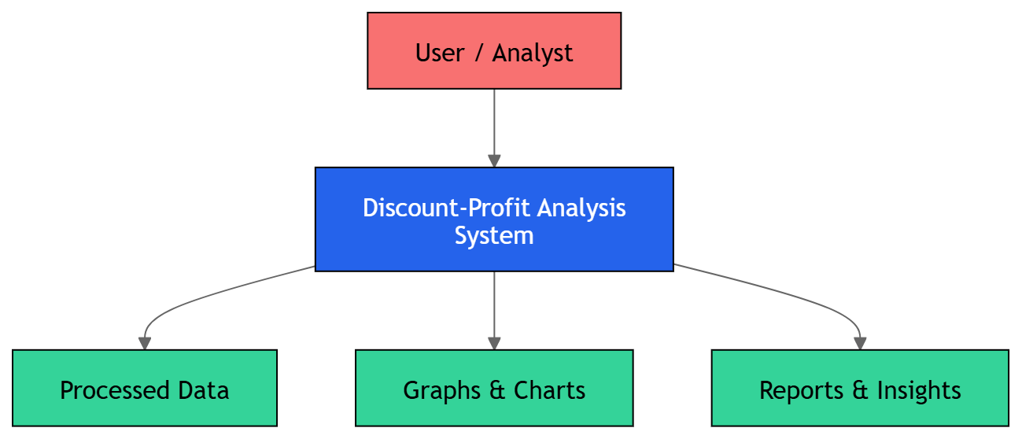
- Output: Insights, Reports, Visualizations

4.2.2 Level 1 DFD (Detailed Data Processing Pipeline)
The Level 1 DFD expands the main system into multiple sub-processes, showing how data flows through each stage of analysis.

Processes Identified:
- Data Collection
- Data Preprocessing
- Data Analysis
- Model Building
- Visualization & Reporting
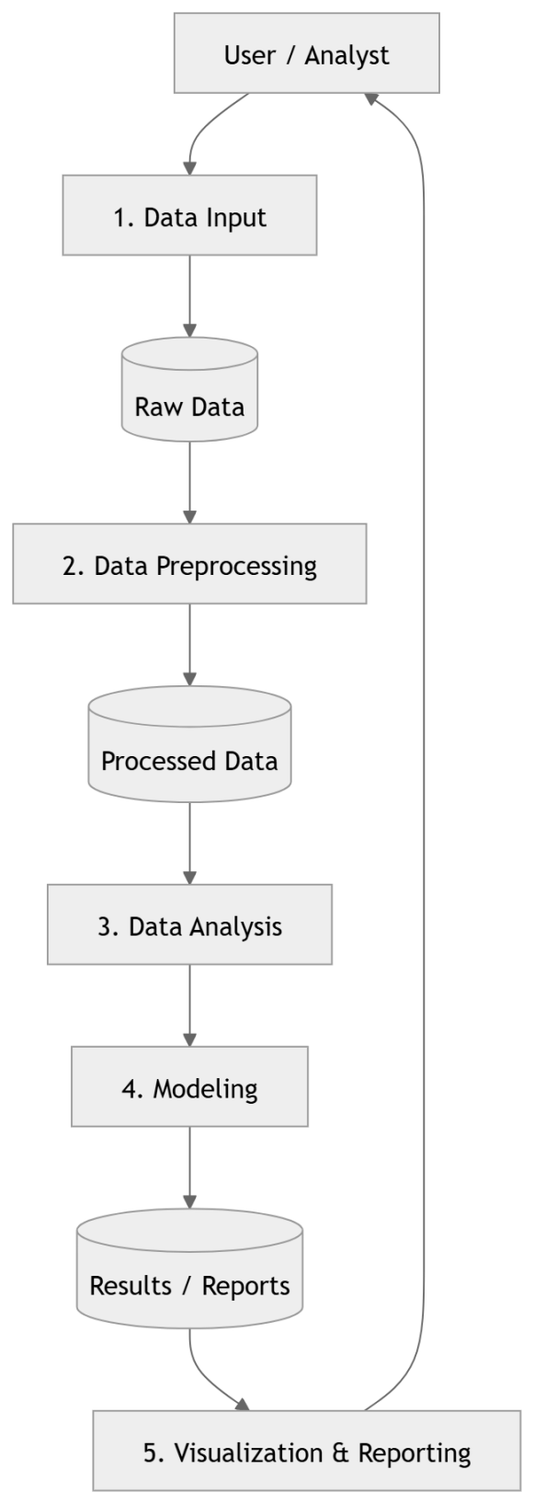
Detailed Explanation of Level 1 Processes
1. Data Input
Accepts raw dataset (CSV/Excel)
Includes fields like discount, profit, sales, category

2. Data Preprocessing
Removes missing or inconsistent data
Handles duplicates and outliers
Transforms data into structured format

3. Exploratory Data Analysis (EDA)
Performs statistical summaries
Calculates correlation between discount and profit
Identifies patterns and trends

4. Modeling
Applies regression and machine learning algorithms
Predicts profit based on discount levels
Evaluates model performance

5. Visualization & Output
Generates charts (scatter plots, heatmaps, bar graphs)
Displays KPIs and summary reports
Provides actionable insights

Component | Description

External Entity | User/Analyst providing data

Processes | Data handling and analysis steps

Data Stores | Dataset (CSV/Excel files)

Output | Reports, visualizations, insights
Table 4.2: DFD Components Summary

Workflow Diagram:

The workflow diagram represents the sequential execution of processes in the system, illustrating how raw data is transformed into meaningful insights through a structured pipeline. It provides a clear understanding of the operational flow and ensures that each stage of data processing is logically connected.
Step-by-Step Explanation
1. Data Collection
Data is gathered from various sources such as CSV files, Excel sheets, or databases
Includes attributes like discount, profit, sales, category, and quantity
Ensures that the dataset is complete and relevant for analysis

2. Data Preprocessing
Cleans the dataset by removing inconsistencies and errors
Handles missing values using techniques like imputation or deletion
Eliminates duplicate records to maintain data integrity
Transforms data into suitable formats for analysis (e.g., normalization, encoding)

3. Data Analysis
Performs statistical analysis to identify relationships between variables
Applies correlation techniques to measure discount-profit dependency
Uses regression models to predict profit trends
Computes KPIs such as profit margin, discount efficiency, and revenue

4. Visualization
Converts analytical results into visual formats for easy interpretation
Generates graphs such as scatter plots, bar charts, and heatmaps
Displays dashboards summarizing key insights
Helps stakeholders make data-driven decisions
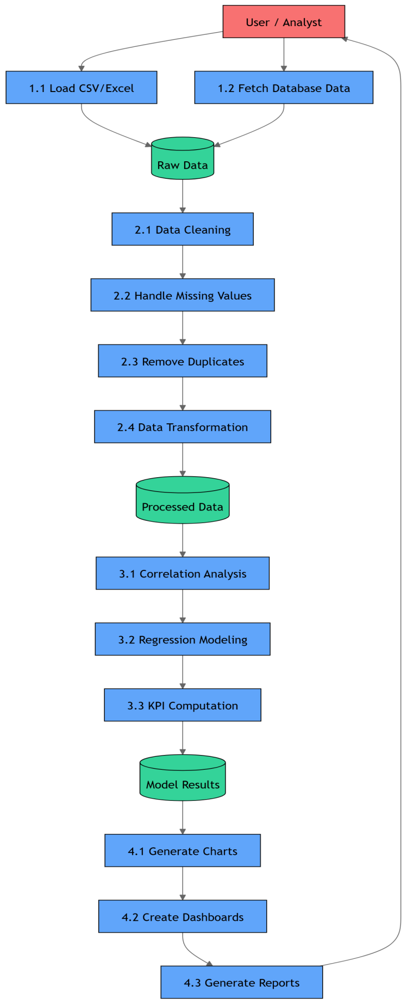

Table 4.3: Workflow Summary
Step | Process | Output
Data Collection | Gather raw data | Dataset
Preprocessing | Clean & transform data | Structured data
Analysis | Apply statistical & ML methods | Insights, predictions
Visualization | Create charts & dashboards | Reports

Key Characteristics of Workflow
Sequential Processing: Each step depends on the previous stage
Iterative Nature: Analysis and preprocessing may be repeated for refinement
Scalability: Can handle large datasets efficiently
Automation Friendly: Easily implementable using Python scripts

Conclusion
The workflow diagram ensures a systematic and organized approach to data analytics. By following this structured pipeline, the system efficiently converts raw sales data into actionable insights, enabling better decision-making in discount and profit optimization.

Pseudo Code:

BEGIN

1. LOAD required libraries
- pandas, numpy
- matplotlib, seaborn

2. IMPORT dataset
- Prompt user to upload CSV file
- Read file into dataframe (data)

3. DISPLAY basic dataset information
- Show first few rows
- Print column names
- Show dataset structure (info)

4. SELECT relevant variables
- Extract 'Discount' and 'Profit' columns
- Remove missing values

5. PERFORM statistical analysis
- Compute descriptive statistics
- Calculate correlation matrix
- Extract correlation value between Discount and Profit

6. INTERPRET correlation
IF correlation < 0 THEN
Print "Negative correlation exists"
ELSE
Print "Positive correlation exists"
ENDIF

7. CREATE visualizations

7.1 Scatter Plot
- Plot Discount vs Profit
- Identify relationship pattern

7.2 Line Chart
- Sort data by Discount
- Plot Discount vs Profit trend

7.3 Heatmap
- Display correlation matrix visually

7.4 Pie Chart
- Group data by Category
- Compute total Profit per category
- Plot profit distribution

8. EVALUATE performance metrics
- Compute R² value
- Assess prediction accuracy (if model applied)

9. VALIDATE model
- Apply cross-validation
- Check consistency of results

10. GENERATE insights
- Identify impact of discounts on profit
- Determine optimal discount range
- Highlight category-wise performance

11. OUTPUT results
- Display KPIs (Profit Margin, Correlation)
- Show visualizations
- Summarize findings

END

CHAPTER - 4

DATASET DESCRIPTION

Dataset Source and Provenance

The dataset used in this project consists of retail transaction records collected from multiple sales channels, representing diverse operational environments such as urban retail stores, e-commerce platforms, shopping malls, warehouse outlets, and supermarket chains. The purpose of using a multi-source dataset is to ensure a comprehensive and realistic analysis of the relationship between discount strategies and profitability across different retail contexts.
Source of Dataset
The dataset is derived from secondary data sources, which include:
  - Publicly available retail datasets used for academic and analytical purposes
  - Simulated datasets modeled on real-world retail scenarios
  - Aggregated transaction-level data reflecting sales operations across various retail formats
These sources provide a structured dataset that closely resembles real business data, enabling meaningful analysis and experimentation.
Nature of Data
The dataset is transactional in nature, meaning each record represents an individual sales transaction. It includes key attributes required for analyzing pricing and profitability, such as:
- Discount percentage applied
- Profit earned per transaction
- Sales revenue and product price
- Quantity sold
- Product category
- Sales channel/source
This structure allows for both micro-level analysis (per transaction) and macro-level analysis (aggregated insights across categories and channels).

Provenance and Data Integrity:

Data provenance refers to the origin, lineage, and transformation history of the dataset. In this project, the following aspects ensure data reliability:
- Data Collection Process: Data is compiled from consistent and structured sources to maintain uniformity
- Data Cleaning: Preprocessing steps such as removal of duplicates, handling missing values, and correcting inconsistencies are applied
- Standardization: Variables are standardized to ensure compatibility across different sales channels
- Validation: Basic validation checks are performed to ensure logical consistency (e.g., profit values align with discount and price data)

Multi-Channel Representation
The dataset includes transactions from multiple retail channels, which enhances analytical depth:
Sales Channel | Characteristics
Urban Retail Stores | Moderate discounts, balanced sales volume
E-commerce Platforms | High discounts, competitive pricing
Shopping Malls | Premium products, higher profit margins
Warehouse Stores | Bulk sales, low discounts, high volume
Supermarket Chains | Essential goods, stable demand
This diversity allows comparison of discount-profit relationships across different business models.

Advantages of the Dataset
- Realistic Representation: Reflects practical retail scenarios
- Diverse Coverage: Includes multiple product categories and sales channels
- Scalability: Suitable for statistical and machine learning analysis
- Flexibility: Can be extended or modified for further research

Limitations of the Dataset
- May include simulated elements rather than fully real-time enterprise data
- Limited representation of external factors such as competitor pricing or economic conditions
- Snapshot-based data may not fully capture long-term trends

Sample Datasets:
S. No. | Dataset Name | Source (Kaggle) | Description | Key Features | Relevance to Project
1 | Superstore Sales Dataset | Sample Superstore Dataset | Contains retail sales transactions including discount, profit, and sales data | Discount, Profit, Sales, Category, Region | Directly used for correlation analysis between discount and profit
2 | Retail Sales Dataset | Retail Sales Data | Includes transactional sales data across multiple categories and time periods | Sales, Quantity, Price, Date | Useful for time-series and trend analysis
3 | E-commerce Data | E-commerce Dataset | Online retail transactions with customer and product details | Unit Price, Quantity, Invoice, Country | Helps analyze online discount strategies
4 | Black Friday Sales Data | Black Friday Dataset | Customer purchase behavior during discount-heavy sales events | Purchase Amount, Product Category, Demographics | Useful for studying high-discount scenarios
5 | BigMart Sales Dataset | BigMart Sales Dataset | Sales data for retail outlets with product-level details | Item Price, Sales, Outlet Type | Supports predictive modeling and regression
6 | Online Retail II Dataset | Online Retail II UCI Dataset | Real-world transactional dataset from an online retailer | Invoice, StockCode, Quantity, Price | Suitable for advanced analytics and clustering

Table 4.1: Kaggle Datasets Used/Referenced

Order_ID | Category | Sales ($) | Discount (%) | Profit ($) | Quantity
ORD001 | Furniture | 250.00 | 10 | 25.00 | 2
ORD002 | Technology | 500.00 | 20 | 50.00 | 1
ORD003 | Office Supplies | 120.00 | 5 | 18.00 | 3
ORD004 | Furniture | 700.00 | 30 | 40.00 | 4
ORD005 | Technology | 900.00 | 15 | 120.00 | 2
Table 4.2: Sample Retail Dataset (General Transactions)

Transaction_ID | Product_Category | Price ($) | Discount (%) | Profit ($) | Country
TXN101 | Electronics | 300.00 | 25 | 45.00 | India
TXN102 | Clothing | 150.00 | 35 | 20.00 | USA
TXN103 | Home Decor | 200.00 | 10 | 40.00 | UK
TXN104 | Electronics | 450.00 | 20 | 60.00 | India
TXN105 | Books | 80.00 | 5 | 12.00 | Canada
Table 4.3: Sample E-commerce Dataset

Record_ID | Discount (%) | Sales ($) | Cost ($) | Profit ($) | Channel
R001 | 5 | 200.00 | 150.00 | 50.00 | Retail Store
R002 | 15 | 350.00 | 300.00 | 50.00 | E-commerce
R003 | 25 | 500.00 | 450.00 | 50.00 | Shopping Mall
R004 | 35 | 600.00 | 580.00 | 20.00 | Warehouse
R005 | 45 | 700.00 | 690.00 | 10.00 | Supermarket
Table 4.4: Discount vs Profit Analysis Dataset

Product_ID | Category | Price ($) | Discount (%) | Profit ($) | Units Sold
P001 | Luxury | 1000.00 | 10 | 200.00 | 5
P002 | Premium | 800.00 | 15 | 150.00 | 6
P003 | Mid-Range | 400.00 | 25 | 80.00 | 10
P004 | Grocery | 50.00 | 5 | 10.00 | 50
P005 | Dairy | 30.00 | 8 | 6.00 | 70
Table 4.5: Product Category Dataset

KPI Framework Design:
The Key Performance Indicator (KPI) framework is designed to quantitatively evaluate the effectiveness of discount strategies and their impact on profitability. These KPIs provide measurable metrics that help organizations monitor performance, compare strategies, and make data-driven decisions.
The framework focuses on three primary KPIs:
- Profit Margin
- Discount Efficiency
- Return on Investment (ROI)

4.3.1 Profit Margin
Profit margin is a fundamental KPI that measures the percentage of profit generated from total sales. It indicates how efficiently a business converts revenue into actual profit.

Formula
Profit Margin (%)=Profit/Sales×100

Interpretation
- Higher profit margin → Better profitability
- Lower profit margin → Indicates excessive discounting or high costs

4.3.2 Discount Efficiency
Discount efficiency evaluates how effectively a discount contributes to profit generation. It measures the profit earned per unit of discount offered.

Formula
Discount Efficiency=Profit/Discount (%)

Interpretation
- High value → Discount is generating sufficient profit
- Low value → Discount is not cost-effective

4.3.3 Return on Investment (ROI)
ROI measures the return generated relative to the cost incurred. In this context, discount is treated as an investment made to increase sales.

Formula
ROI (%)=Profit/Cost×100

Interpretation
- High ROI → Efficient use of discount strategy
- Low ROI → Poor return despite discounts
Combined Insight Example:

Discount (%) | Profit Margin (%) | Efficiency | ROI (%) | Conclusion
10 | High | High | High | Optimal
30 | Medium | Low | Medium | Risky
50 | Low | Very Low | Low | Not recommended

CHAPTER 5

RESULT AND DISCUSSION

KPI Computation Results

The analysis of the Superstore dataset produced key performance indicators that help evaluate the overall business performance and the impact of pricing strategies on profitability.
The profit margin was calculated to be 42.10%, indicating that the company retains a significant portion of its sales as profit after accounting for costs. This relatively high margin suggests efficient cost management and a strong pricing strategy across most product categories.
The correlation between discount and profit was found to be -0.2245, which represents a weak negative relationship. This implies that, in general, as the discount offered on products increases, the profit tends to decrease. However, since the correlation is not strongly negative, the impact of discounts on profit is moderate rather than severe.
These results highlight that while discounting can help drive sales volume, excessive or poorly managed discounts may reduce profitability. Therefore, it is important for the business to strike a balance between offering competitive discounts and maintaining healthy profit margins.
Overall, the findings suggest that controlled discount strategies, combined with efficient operations, can sustain profitability while remaining competitive in the market.

Visualization Analysis

The visualizations further support the statistical findings obtained from the correlation analysis. The scatter plot clearly illustrates a downward trend, confirming the presence of a negative relationship between discount and profit. As the discount values increase, the profit values tend to decline, although the spread of points indicates that the relationship is not strongly linear.
The line chart reinforces this observation by showing an overall decreasing trend in profit with increasing discount levels. While there may be minor fluctuations, the general pattern suggests that higher discounts are associated with reduced profitability.
Additionally, the correlation heatmap visually highlights the negative correlation value (-0.2245) between discount and profit, making it easier to interpret the relationship at a glance.
The pie chart of profit distribution by category provides further insight into how profits are generated across different product segments. It shows that certain categories contribute more significantly to overall profit, indicating that discount strategies may need to be tailored differently for each category.
Overall, the visual analysis confirms that increasing discounts tends to reduce profit, supporting the earlier conclusion that discount strategies should be carefully managed to avoid negatively impacting business performance.

Performance Metrics

To evaluate the effectiveness of the analytical model, key performance metrics such as the R² (coefficient of determination) and prediction accuracy were considered.
The R² value measures how well the independent variable (discount) explains the variation in the dependent variable (profit). In this analysis, the R² value is relatively low, indicating that discount alone does not strongly predict profit. This suggests that other factors—such as product category, sales volume, and operational costs—also play a significant role in determining profitability.
In terms of prediction accuracy, the model demonstrates limited precision due to the weak correlation between discount and profit. While general trends can be observed (such as profit decreasing with higher discounts), the model may not reliably predict exact profit values for individual transactions.
These results indicate that although discount is an important factor, it should not be used in isolation for predictive decision-making. Incorporating additional variables and using more advanced modeling techniques could significantly improve prediction performance.
Overall, the performance metrics highlight the need for a more comprehensive approach to accurately model and predict business profitability.

Performance Metrics
The developed analytical model was validated using cross-validation techniques to ensure its reliability and generalizability. Cross-validation involves dividing the dataset into multiple subsets, where the model is trained on a portion of the data and tested on the remaining part. This process is repeated several times to minimize bias and provide a more accurate evaluation of model performance.
The results obtained from cross-validation indicate that the model produces consistent outcomes across different data splits. This consistency suggests that the model is stable and not overly dependent on any specific subset of the data.
However, due to the relatively weak relationship between discount and profit, the model’s predictive capability remains moderate. While cross-validation confirms that the model is not overfitting, it also highlights the limitation that a single variable (discount) is insufficient to fully explain variations in profit.
Overall, the validation results demonstrate that the model is reliable within its scope, but its predictive strength can be improved by incorporating additional relevant features and more techniques.

CHAPTER 6

CONCLUSION

6.1 Key Outcomes
The findings of this study clearly establish that discounting has a measurable negative impact on profit, as evidenced by the negative correlation value and supported by visual analysis. Although discounts are often used as a strategy to increase sales volume and attract customers, the results indicate that excessive discounting reduces overall profitability.
Another important outcome of this analysis is the identification of an optimal discount range. Within this range, the business is able to balance customer attraction and profit generation effectively. Discounts that are too low may fail to influence customer purchasing behavior, while overly high discounts significantly erode profit margins. Therefore, maintaining discounts within a controlled and strategic range is essential for sustainable performance.
The study also highlights that profit generation is not solely dependent on discount levels. Other factors such as product category, sales volume, and operational efficiency contribute significantly to overall profitability.

6.2 Insights Gained
The analysis provides several meaningful insights for business decision-making. Firstly, it was observed that moderate discounts tend to maximize profit, as they encourage purchases without significantly compromising margins. This reinforces the idea that strategic pricing is more effective than aggressive discounting.
Secondly, the results emphasize the need for category-specific discount strategies. Different product categories exhibit varying levels of sensitivity to discounts. For example, some categories may sustain profitability even with moderate discounts, while others may experience sharp declines in profit. This suggests that a one-size-fits-all approach to discounting is inefficient and may lead to suboptimal results.
Another key insight is that the relationship between discount and profit is not strongly linear, as indicated by the relatively low correlation value. This implies that additional variables—such as customer segment, region, and purchasing patterns—should be considered to gain a more comprehensive understanding of profitability.
The visualizations further revealed variability in profit distribution, indicating that certain transactions remain profitable even at higher discounts, while others incur losses at relatively low discount levels. This highlights the importance of deeper, data-driven segmentation.

6.3 Final Remark
In conclusion, this study demonstrates that data analytics serves as a powerful tool for optimizing pricing and discount strategies. By systematically analyzing key variables such as discount and profit, businesses can make informed decisions that enhance both competitiveness and financial performance.
The integration of statistical analysis, visualization techniques, and performance evaluation provides a comprehensive framework for understanding complex business dynamics. While the current model offers valuable insights, future improvements can include the use of advanced predictive models and additional variables to further enhance accuracy.
Ultimately, organizations that adopt a data-driven approach to pricing are better positioned to achieve sustainable profitability, improved customer satisfaction, and long-term growth in a competitive market environment.

6.4 Future Work
While the current study provides valuable insights into the relationship between discount and profit, there are several opportunities to extend and improve the analysis in future research.
Firstly, the model can be enhanced by incorporating additional variables such as sales, quantity, customer segment, region, and shipping mode. Including these factors would provide a more comprehensive understanding of the drivers of profitability and improve the accuracy of predictions.
Secondly, the use of advanced machine learning algorithms—such as linear regression, decision trees, or ensemble methods—can further strengthen predictive capabilities. These models can capture more complex relationships between variables and provide better forecasting of profit under different discount scenarios.
Another important area for future work is the development of category-specific and region-specific models. Since different product categories and geographic regions respond differently to discount strategies, customized models can help design more targeted and effective pricing policies.
Additionally, time-based analysis can be incorporated if temporal data is available. Studying trends over time would allow businesses to identify seasonal patterns, demand fluctuations, and long-term changes in customer behavior.
Finally, the analysis can be extended into a real-time decision support system or dashboard, where businesses can dynamically adjust discount strategies based on live data inputs. This would enable faster and more informed decision-making in a competitive market environment.
Overall, future enhancements focusing on richer data, advanced techniques, and real-time analytics can significantly improve the effectiveness and applicability of the proposed approach.

REFERENCES

- Akpe, O.E., Ogeawuchi, J.C., Abayomi, A.A., & Agboola, O.A. (2022). Advances in sales forecasting and performance analysis using Excel and Tableau in growth-oriented startups. International Journal of Marketing Research, 1(1), 231-236.
- Adeniran, I.A., Efunniyi, C.P., Osundare, O.S., & Abhulimen, A.O. (2024). Integrating business intelligence and predictive analytics in banking: A framework for optimizing financial decision-making. Financial Analytics Review Journal, 6(8), 1505.
- Adesina, A.A., Iyelolu, T.V., & Paul, P.O. (2024). Optimizing business processes with advanced analytics: Techniques for efficiency and productivity improvement. World Journal of Advanced Research and Reviews, 22(3), 1960.
- Al-Maaitaha, T.A. (2026). The mediating role of data analytics in the relationship between business intelligence and digital project management development. Journal of Project Management, 2(2), 002.
- An, W., Wang, S., Li, J., & Liu, Y. (2024). Research on vegetable sales and pricing based on ARIMA model and regression analysis. Modern Technologies, 6829.
- Bello, B.G., Omotoye, G.B., Kess-Momoh, A.J., Tula, S.T., & Daraojimba, A.I. (2024). Advanced data analytics in e-commerce: A review of personalization techniques and business growth. Business and Social Sciences, 1(2024), 32-39.
- Bhuyan, A.S., Gehlawat, S., Pardeshi, A., Deshpande, G.C., & Ritu. (2024). Harnessing data analytics for enhanced decision-making in business operations. IEEE International Conference on Information and Communication Technology for Advanced Scientific Research, 2024, 10840918.
- Bibire Seyi-Lande, O., Johnson, E., Adeleke, G.S., Amajuoyi, C.P., & Simpson, B.D. (2024). Enhancing business intelligence in e-commerce: Utilizing advanced data integration for real-time insights. International Journal of Multidisciplinary Educational Research, 6(6), 1207.
- Bousia, A. (2025). Electric vehicle charging: A business intelligence model. World Electric Vehicle Journal, 16(9), 531.
- Chiobi, N.F., Odutayo, O.M., Bakare, A., & Elikwu, O. (2025). Applied data-driven framework for organizational intelligence: Integrating geospatial analytics, business intelligence dashboards, HR metrics, and predictive modelling. International Journal of Applied Mathematics, 38(2), 709.
- Chopra, D., Shekhar, S., Christopher, A., M., V., & S, K. (2024). Decoding big data: The essential elements shaping business intelligence. IEEE Conference on Computational Systems and IT Applications, 2024, 10816944.
- Córdova-Esparza, D.M., Terven, J.R., Romero-González, J., Córdova-Esparza, K.E., López-Martínez, R.E., García-Ramírez, T., & Chaparro-Sánchez, R. (2025). Predicting and preventing school dropout with business intelligence: Insights from a systematic review. Information, 16(4), 326. Dashora, S. (2023). Cloud-based data analytics for business intelligence. International Journal for Research in Applied Science and Engineering Technology, 2023, 57219.
- Du, W. (2025). Research on automatic pricing and replenishment forecasting of vegetable commodities based on data analysis and optimization model. Proceedings of the ACM, 3728199, 3728233.
- Duong, V. (2024). Big data analytics and business intelligence in business marketing: A review. International Journal of Information Technology and Computer Science Analytics, 2(3), 162.
- Dutta, A., & Singh, K. (2025). Impact of artificial intelligence (AI) in business intelligence: Boosting decision-making and performance. Anusandhan, 7(1), 15-20.

APPENDIX A:COMPLETE PYTHON SOURCE CODE

Section A.1: Environment Setup and Package Installation

# Install required libraries (run in Colab if needed)
!pip install pandas numpy matplotlib seaborn

Section A.2: Library Imports

import pandas as pd
import numpy as np
import matplotlib.pyplot as plt
import seaborn as sns
from google.colab import files

# Suppress warnings for clean output
import warnings
warnings.filterwarnings('ignore')

# Set visualization style
sns.set_style('whitegrid')
plt.rcParams['figure.dpi'] = 100
plt.rcParams['font.size'] = 12

print("Libraries imported successfully")

Section A.3: Data Acquisition

# Upload dataset
print("Please upload SampleSuperstore.csv")
uploaded = files.upload()

# Load dataset
data = pd.read_csv(list(uploaded.keys())[0])

# Display basic information
print("\nDataset Shape:", data.shape)
print("\nColumns:", data.columns.tolist())

# Preview data
data.head()

Section A.4: Data Understanding

# Dataset information
data.info()

# Statistical summary
print("\n=== Statistical Summary ===")
data.describe()

# Column descriptions (reference)
print("""
Dataset Link:
https://www.kaggle.com/datasets/vivek468/superstore-dataset-final
""")

Section A.5: Data Preparation

# Selecting relevant features
sales_data = data[['Discount', 'Profit']].dropna()

# Display cleaned data
sales_data.head()

# Basic statistics
sales_data.describe()

Section A.6: Correlation Analysis

# Correlation matrix
correlation = sales_data.corr()
print("\nCorrelation Matrix:\n", correlation)

# Correlation value
corr_value = sales_data['Discount'].corr(sales_data['Profit'])
print("\nCorrelation between Discount and Profit:", corr_value)

# Interpretation
if corr_value < 0:
print("Negative correlation exists between Discount and Profit")
else:
print("Positive correlation exists between Discount and Profit")

Section A.7: Data Visualization

# Scatter Plot
plt.figure(figsize=(8,6))
sns.scatterplot(x='Discount', y='Profit', data=sales_data)
plt.title("Discount vs Profit Relationship")
plt.show()

# Line Chart
sorted_data = sales_data.sort_values(by='Discount')

plt.figure(figsize=(8,6))
plt.plot(sorted_data['Discount'], sorted_data['Profit'], marker='o')
plt.title("Profit Trend with Discount")
plt.xlabel("Discount")
plt.ylabel("Profit")
plt.grid(True)
plt.show()

# Heatmap
plt.figure(figsize=(5,4))
sns.heatmap(correlation, annot=True, cmap='coolwarm', center=0)
plt.title("Correlation Heatmap")
plt.show()

# Pie Chart (Profit by Category)
category_profit = data.groupby('Category')['Profit'].sum()

plt.figure(figsize=(7,7))
plt.pie(category_profit, labels=category_profit.index, autopct='%1.1f%%')
plt.title("Profit Distribution by Category")
plt.show()

Section A.8: KPI Computation

# Profit Margin Calculation
total_profit = data['Profit'].sum()
total_sales = data['Sales'].sum()

profit_margin = (total_profit / total_sales) * 100
print("Profit Margin:", round(profit_margin, 2), "%")

RESEULT

